INTERNATIONAL ORGANISATION FOR STANDARDISATION
ORGANISATION INTERNATIONALE DE NORMALISATION
ISO/IEC JTC 1/SC 29/WG 3
CODING OF MOVING PICTURES AND AUDIO

ISO/IEC JTC 1/SC 29/WG 3 m 56339
Online – April 2021

Title: Adding support for sweep gradients in ISO/IEC 14496-22 AMD2
Authors: Peter Constable, Cosimo Lupo, Dominik Röttsches, Roderick Sheeter, Vladimir Levantovsky (on behalf of AHG)

There are three types of commonly recognized color gradients, including linear, radial, and sweep (or angular) gradients that should be supported by COLR table. This contribution proposes new updates to enable support of sweep gradients as part of the COLR version 1 table format defined by the Working Draft of ISO/IEC 14496-22:2019/AMD2.

5.7.11.1.2 “Gradients”
Replace the first paragraph with the following:
COLR version 1 supports three types of gradients: linear gradients, radial gradients, and sweep gradients. For each type, non-variable and variable formats are defined. Each type of gradient is specified using a color line.
5.7.11.1.2.1 “Color Lines”
Replace the first two paragraphs with the following:
A color line is a function that maps real numbers to color values to define a one-dimensional gradation of colors, to be used in the definition of linear, radial, or sweep gradients. A color line is defined as a set of one or more color stops, each of which maps a particular real number to a specific color.
On its own, a color line has no positioning, orientation or size within a design grid. The definition of a linear, radial, or sweep gradient will reference a color line and map it onto the design grid by specifying positions in the design grid that correspond to the real values 0 and 1 in the color line. The specification for linear, radial and sweep gradients also include rules for where to draw interpolated colors of the color line, following from the placement of 0 and 1.
5.7.11.1.2.1 “Color Lines”
Add the following note after the last paragraph in the current text of the sub clause:
NOTE Special considerations apply to color line extend modes for sweep gradients. See 5.7.11.1.2.4 for details.
5.7.11.1.2 “Gradients”
Add the new sub clause 5.7.11.1.2.4 “Sweep gradients” with the following text (and renumber the remaining figures within the clause 5):
5.7.11.1.2.4 Sweep gradients
A sweep gradient provides a gradation of colors that sweep around a center point. For a given color on a color line, that color projects as a ray from the center point in a given direction. This is illustrated in figure 5.29.
NOTE The following figures illustrate sweep gradients clipped to a circular region. Sweep gradients are not bounded, however, and fill the entire space.
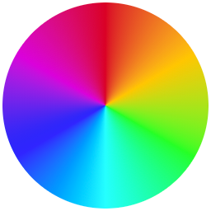
Figure 5.29 Sweep gradient
NOTE In some contexts, this type of gradient is referred to as a “conic” gradient, or as an “angular” gradient.
A sweep gradient is defined by a center point, starting and ending angles, and a color line. The angles are expressed in counter-clockwise degrees from the direction of the positive x-axis on the design grid.
The color line is aligned to a circular arc around the center point, with arbitrary radius, with stop offset 0 aligned with the starting angle, and stop offset 1 aligned with the ending angle. The color line progresses from the start angle to the end angle in the counter-clockwise direction; for example, if the start and end angles are both 0°, then stop offset 0.1 is at 36° counter-clockwise from the direction of the positive x-axis. For each position along the circular arc, from start to end in the counter-clockwise direction, a ray from the center outward is painted with the color of the color line at the point where the ray passes through the arc.
The color line may be defined using color stops outside the range [0, 1], and color stops outside the range [0, 1] can be used to interpolate color values within the range [0, 1], but only color values for the range [0, 1] are painted. If the specified color stops cover the entire [0, 1] range (or beyond), then the extend mode is not relevant and may be ignored. If the specified color stops do not cover the entire [0, 1] range, the extend mode is used to determine color values for the remainder of that range. For example, if a color line is specified with two color stops, red at stop offset 0.3 and yellow at stop offset 0.6, and the pad extend mode is specified, then the extend mode is used to derive color values from 0.0 to 0.3 (red), and from 0.6 to 1.0 (yellow).
Because a sweep gradient is defined using start and end angles, the gradient does not need to cover a full 360° sweep around the center. This is illustrated in figure 5.30:
Figure 5.30 A sweep gradient with start angle of 30° and an end angle of 150°
Start and end angle values can be outside the range [0, 360), but are interpreted as values within that range by applying a modulus operation. For example, an angle -60° is treated the same as 300°; an angle 480° is treated the same as 120°. As a consequence, the [0, 1] range of the color line covers at most one full rotation around the center, never more.
If the starting and ending angle are the same, a sharp color transition can occur if the colors at stop offsets 0 and 1 are different. This is illustrated in figure 5.31, showing a gradient from red to yellow that starts and stops at 0°:
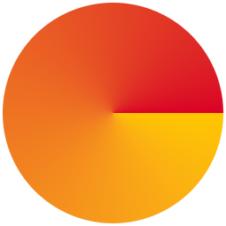
Figure 5.31 A sweep gradient with a sharp transition at the start/end angle 0°
To avoid such a sharp transition, the stop offsets 0 and 1 on the color line need to have the same color value. Figure 5.32 illustrates a sweep gradient that transitions from red at stop offset 0, to yellow at stop offset 0.5, and back to red at stop offset 1.0:
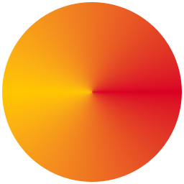
Figure 5.32 A sweep gradient with a smooth transition at the start/end angle 0°
NOTE When a sweep gradient is combined with a transformation (see 5.7.11.1.5), the appearance will be the same as if a circular arc of some non-zero radius were computed from the start and end angles; the center point and arc transformed; the color line aligned to the transformed arc; and then a gradient derived from the result, with rays from the transformed center point passing through the transformed color arc. When aligning the color line to the transformed arc, stop offset 0 would be aligned to the transformed point derived from the start angle, with stop offset 1 aligned to the transformed point derived from the end angle. Thus, a transform can result in the color line progressing in a clockwise rather than counter-clockwise direction.
Sweep gradients are specified using a PaintVarSweepGradient or PaintSweepGradient table, with or without variation support, respectively. See 5.7.11.2.5.5 for format details.
See 5.7.11.1.3 for details on how fills are applied to a shape.

